Pr.1. Upravte algebrické výrazy:
a) a – b - [c – a – (b + a)] – ( -a – c) + b = ?
a – b - [c – a – (b + a)] – ( -a – c) + b = a – b - [c – a –b - a] + a + c + b = 2a + c - [c -2a -b] = 2a + c – c + 2a + b = 4a + b
b) (3x – 2y) / 3 – (4y – 2x) / 6 + (19y – 3x) / 12 = ?
(3x – 2y) / 3 – (4y – 2x) / 6 + (19y – 3x) / 12 = [(3x – 2y).4 - (4y – 2x).2 + (19y – 3x)] / 12 = (12x – 8y – 8y + 4x + 19y – 3x) / 12 = (13x + 3y) / 12
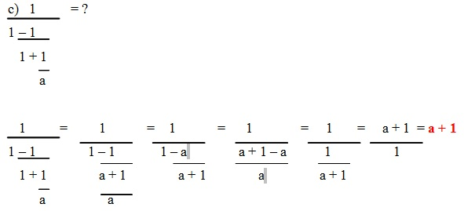
Uprav dané výrazy:
1. (1,5x – 1,4y – 1,7) – (-1,7y – x + 2,2) =
2. 2a - {-3a - 7b - [-4a – 5b – (a – 10b) - a] – 3a} + b =
3. m + [ -10n – ( -6n - 5m)] =
4. 3a – 2ab + 5 – (a – c + 3ab – 4) =
5. (21x + 8y – 4y - p) .(-3) =
6. (a – 3b + c) . 11 – 9a – 6b =
7. (a – b) / (a + b) : (1 – a/b) =
8. (1 – 2/(a + 1)) . (1 – 2 /(a – 1)) =
9. (a/b – b/a) . ab / (a – b) =
10. (( a-3)/(1+3a) – (a-4)/(1+4a)) : (1+ (a-3)/(1+3a).(a-4)/(1+4a)) =
11. Aký výraz musíme pričítať k výrazu 5a – 7b + 3a – (2a + b) aby sme dostali výraz 4a – 14b + (2a – 7b) – 3a?

